http://scienceview.berkeley.edu/VI/worksheet_longtutorial.html

Longitude Tutorial
Finding your Location ( Where are you?)
Step 1
You can express your position by Latitude and Longitude
Step 2
Mapmakers or geographers use an imaginary grid to locate place on a map. This grid is made up of intersecting lines of latitude and longitude.
Step 3
Lines of latitude run east and west around the globe. The latitude is measured in degrees north and south from the Equator.
Lines of longitude that run north and south from North pole to the South pole are measured in degrees east and west from the Prime Meridian
Step 4
Prime Meridian runs through Greenwich, England. It is the planet’s "home base".
Step 5
When we've learned the following three basic ideas, you can find the longitude of your location with an accurate sense of time. Before you can do any longitude calculations, you must convert your local zone time, as shown on your watch, to GMT (Greenwich Mean Time: the clock time back at Greenwich).
Step 6
The local zone time is the local clock time which is the mean solar time of central meridian of your local time zone.
In several places in the world, hundreds of different times were adopted, each one corresponding to its own meridian. To simplify this situation, the Earth surface was divided into 24 time zones, each one delimited by two meridian forming a hour angle of 1 hour at the poles. The mean solar time of the central meridian of each time zone was assigned by convention to all places belonging to the time zone. For political and administrative reasons, often the time zones are delimited by state borders instead of meridians.
<Three Basic Ideas to find Longitude>
Step 7
Basic Idea1: The first of these ideas is the relationship between time and the rotation of the Earth. It takes an average time of 24 hours for the Earth to rotate 360 degrees. If you divide the number degrees in a circle by the number of hours in a day, we find that the Earth turns 15 degrees each hour.
360° / 24 hours = 15° per hour
We can take this a step further and state that the Earth turns one degree in four minutes.
1 hour = 60 minutes / 15° = 4 minutes per degree
Step 8
Basic Idea 2: The second idea is that we have to be careful about the difference between the events and time. Events like sunrise in the east always happen before the same event in the west. But time as shown on eastern clocks is later than on western clocks at the same instant. We can summarize this concept:
Local time earlier, position is westward.
Local time later, position is eastward.
Step 9
Basic Idea 3: The third and last idea needed for longitude is the applying of Equation of Time.
Whenever I've mentioned clock time, I've called it average time. Clock time and Sun time are different by as much as 16.5 minutes. The important thing is that if you're going to compare Sun time to the chronometer's clock time, you have to change the chronometer's clock time to Sun time so that you're comparing like terms. And that's what the Equation of Time does. You can find the Equation of Time from the Equation of Time graph .
By applying the Equation of Time to the chronometer's clock time, we convert Greenwich Mean Time (GMT:Clock time.) to Greenwich Apparent Time (GAT:Sun time). GAT is simply the Sun time back at Greenwich, England.
Step 10
Now we can observe Local Apparent Noon and do our simple subtraction of GAT to find our longitude.
It is noon at the very instant that the sun were right over your head.
Local Apparent Noon is simply noon for your exact location, and sets your watch to 12:00 based on Sun Time. The time of Local Apparent Noon, recorded as 12:00 local time, is compared to the time back in Greenwich
Step 11
<Where are you?>
At the landing point (Kyongju, 35.843°N, 129.2°E),
Local Apparent Noon is observed at 3:43GMT.
Local Apparent Noon => 3: 29 GMT, July 31, 1999
Equation of Time = -0:06 min.
Step 12
1. Apply Basic Idea 3
You have to convert the chronometer's clock time to Sun time by applying the Equation of Time.
3:29 GMT
-0:06 Equation of Time (Student can find the Equation of Time from the Equation of Time graph in Reference)
------------------------------------------------------------------------
3:23 GAT
Step 13
2. ApplyBasic Idea 2
We recorded LAN at 12:00 local time and that's later than 03:37 Greenwich Apparent Time, so we must be to the east of the Prime Meridian.
Step 14
3. Apply Basic Idea 1
We convert the time to degrees of east longitude by calculating the time difference. LAN can be written above or below GAT.
12:00 LAN
-03:23 GAT
------------------------------------------------------------------------
08:37
8 hours * 15 °/hour = 120°
37 minutes / 4 minutes/°= 9.25°
[lambda] = 129.25° E ( or 129° 15' E)

_{i} Description for longitude and latitude
Mapmakers or geographers use an imaginary grid to locate place on a map. This grid is made up of intersecting lines of latitude and longitude. Since the English were the ones drawing the line we use today, they put it through their favorite country. England had the world’s largest navy at the time and they made the rule. This is just a line on the globe. It is called the Prime Meridian which runs through Greenwich, England. It is the planet’s "home base". The other really important line on the globe is the equator, which runs like a belt around the middle of the globe. It is halfway from one pole to the next
Of course, the equator and Prime meridian are not the only two lines marked on the globe. Most maps show many lines running like belts around the globe, and many lines running up and down. Together, they make a grid over the globe. The "belt" lines are called "line of Latitude or parallels." Lines of latitude run east and west around the globe. The latitude is measured in degrees north and south from the Equator; the lines that run north and south from North pole to the South pole are called "Longitude lines or meridians." Lines of longitude are measured in degrees east and west from the Prime Meridian.
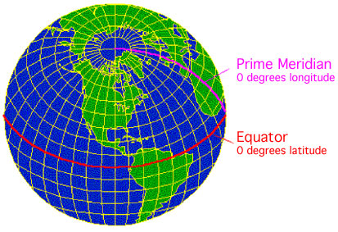
_{ii} Time zones
In several places in the world, hundreds of different times were adopted, each one corresponding to its own meridian. To simplify this situation, the Earth surface was divided into 24 adjacent, equal and equatorially perpendicular wedges, called time zones, each one delimited by two meridian forming a hour angle of 1 hour at the poles. The mean solar time of the central meridian of each time zone was assigned by convention to all places belonging to the time zone. The Greenwich time zone, centered on the homonymous meridian, was taken as reference time zone. In this way, the time zone right eastward Greenwich is 1 hour in advance in comparison with universal time (UT +01:00), while the time zone right westward Greenwich is 1 hour late (UT -01:00) and so on for all the others. The time zones division was officially adopted on 1884 November 1 at the International Meridian Conference held at Washington D.C.
It can be immediately noted that for political and administrative reasons, often the time zones are delimited by state borders instead of meridians. For each time zone it is shown the time when at the Greenwich time zone it is 12:00. In the diametrically opposed time zone, with time 00:00, it is shown the change of date line (dashed line), by convention at the left of this line it is the following day, while at the right it is the preceding day
The figure below shows the time zones division of the world.
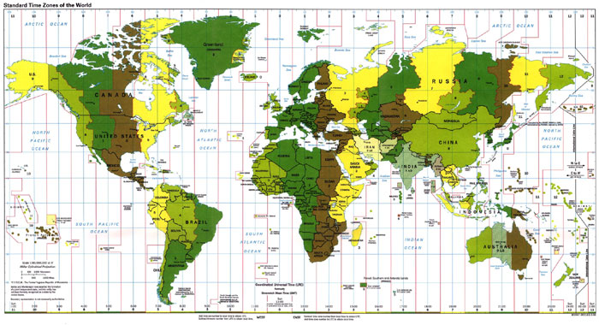
_{iii} The equation of time
Since time began, the time flow on the Earth is ruled by the apparent motion of the Sun in the sky. The time was measured for millennia, measuring the hour angle ( 1 round angle = 24 hour angle) between the current position of the Sun and the highest point above the horizon reached by the Sun each day, defined as corresponding to 12 hours or noon. This measure of time gives the true solar time.
Unfortunately, the apparent solar motion is anything but uniform along the year. Indeed, the Sun reach the highest position above horizon with a delay or an advance of time that changes every day and has a maximum of about 15 minutes. This phenomenon is due in part to the inclination of the terrestrial rotation axis on the plane of the Earth orbit around the Sun and in part to the unequal motion of the Earth around the Sun, caused by the elliptical orbit.
To avoid this drawback, it was defined the mean solar time that has the mean solar day, equal to the mean duration of all days of year, as measurement unit. To the definition of this time, it is associated an ideal Sun, called mean Sun, that has an uniform apparent motion.
The difference between the true solar time and the mean solar time changes continuously day by day with an annual cycle. This quantity is known as the equation of time.
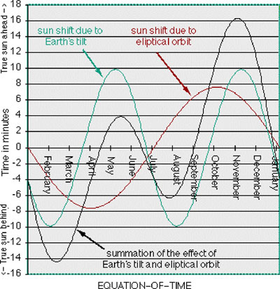

Reference:
http://www2.gsoc.dlr.de/scripts/satvis/countries.asp
http://shiva.pub.getty.edu/tgn_browser/
http://www.hyperhistory.com/online_n2/History_n2/a.html
http://www-chaos.umd.edu/history/time_line.html
http://www.asian.gu.edu.au/
http://unix6.nysed.gov/pubs/gis/gisindex.htm
http://www.analemma.com/pages
http://www.fourmilab.ch/cgi-bin/uncgi/solar
http://times.clari.net.au/location.php3/asia/seoul
http://130.11.63.183/scripts
http://vortex.plymouth.edu/sun/sun4a.html
http://www.analemma.com/pages/introduction/introduction.html
http://indy4.fdl.cc.mn.us/~isk/stars
http://www.pbs.org/wgbh/nova/teachersguide/longitude
Return to Home Page

